**SUPPLEMENTARY MATERIALS**

**MATERIAL AND METHODS**

***Cell culture***

The TNBC cell line MDA-MB-231 was obtained from the American Type Culture Collection and cultured in DMEM complete medium. For hormone-responsive experiments, MDA-MB-231 cells were maintained in phenol red-free medium with 5% charcoal-stripped fetal bovine serum for 3 days and then treated with vehicle and different ligands.

***RNA-seq***

MDA-MB-231 cells were treated with 100nM Dex or 10 mM CpdA for 2 and 4 h, respectively. RNA was extracted using the RNeasy Mini Kit (Qiagen, Valencia, CA). Complementary DNA libraries were constructed using the Illumina Truseq RNA Sample Prep Kit according to the manufacturer’s protocol. Fifty base pairs of single-end reads were generated on the Illumina HiSeq 2500 platform with three multiplexed samples per lane.

***Sequence data processing and quality assessment***

RNA-seq data was processed from FASTQ files. The initial quality of raw reads was assessed using FastQC v.0.11.9 (<https://www.bioinformatics.babraham.ac.uk/projects/fastqc/>). Low quality bases were trimmed from the reads using Trimmomatic v.0.40 (TrimmomaticSE with parameters ILLUMINACLIP:TrueSeq3-SE.fa:2:30:10 LEADING:3 TRAILING:3 SLIDINGWINDOW:4:15 MINLEN:33)26, and the quality of trimmed reads was inspected as previously.

***Read alignment***

After read trimming, the resulting reads were aligned to the human reference genome GRCh38 using HISAT2 with parameters allowing two primary alignments and maximum and minimum mismatch penalties to be 6 and 2, respectively27. SAM file outputs from the aligner were converted into BAM files and index files were generated for them using SAMtools28. Alignment quality control was conducted using RSeQC v5.0.1 to check basic BAM statistics and read distribution statistics of each sample with bam_stat.py and read_distribution.py, respectively29.

***Read counting***

Read counting of aligned reads was conducted using featureCounts function from R package Rsubread v.1.34.730. For featureCounts parameters, the feature and attribute types were specified to be exon and gene_id, respectively, read counting was set as unstranded, counting of multimapping reads or chimeric fragments were not allowed, the minimum mapping quality was required to be 0, and read summarization was performed at meta-feature level.

***Sample quality assessment***

For sample-level quality assessment, the gene expression counts were transformed into normalised counts using varianceStabilizingTransformation function from Bioconductor R package DESeq217. To identify differences between samples, outlier samples and other biases in the data, a principal component analysis (PCA) was conducted using the function plotPCA from DESeq2, and a heatmap was generated from a subset of genes using the function Heatmap from R package ComplexHeatmap31.

***Differential gene expression analysis***

Differential expression analysis was conducted using R packages edgeR and limma from Bioconductor18,19, and followed the workflow described in Law et al. 201832. In brief, a DGEList object was created from the counts table, and a separate data frame was added to it to contain information of gene annotations that were derived from Homo.sapiens R package. Genes that were lowly expressed or had zero count across all samples, were removed using filterByExpr function. Gene expression distributions were normalised and unsupervised clustering was performed using the function plotMDS to inspect the effect of filtering on the similarity of samples. Design matrix and contrasts were created using the functions model.matrix and makeContrasts, respectively. The function voom was used to remove heteroscedascity from count data and linear models were fitted for comparisons of interest using functions lmFit and contrasts.fit. Empirical Bayes moderation was carried out using the function eBayes. The number of DE genes and individual DE genes in each comparison were examined using decideTests and topTable functions, respectively. Significantly differentially expressed genes were determined using adjusted p-value < 0.05.

***Pathway enrichment analysis***

For the pathway enrichment analysis, genes with log-fold change ≥ 1 or ≤ -1 were extracted from the list of differentially expressed genes. Enrichr was used to obtain enriched pathways for significantly up- and downregulated genes separately in each comparison22. From the Enrichr results, pathways from Reactome 2020 database and disease from ClinVar 2019 database were studied closer. The analysis results were sorted by p-value.

**Supplementary Figure 1. Per base quality scores prior to read trimming.** The distribution of quality scores at each position in the read across all reads in the sample Dex_2h_rep1 are plotted in the graph. In the plot, the red line represents the median value, yellow box represents the inter-quartile range (25-75%), the upper and lower whiskers represent the 10% and 90% points, and the blue line indicates the mean quality. The quality scores are shown on the y-axis and base pair position on the x-axis.

**Supplementary Figure 2. Quality score distribution of sequences prior to read trimming.** The plot represents the distribution of average quality scores in the sample Dex_2h_rep1. The average quality score is shown on the x-axis and the number of sequences with the given average on the y-axis.

**Supplementary Figure 3. Per base quality scores after read trimming.** The distribution of quality scores at each position in the read across all reads in the sample Dex_2h_rep1 after conducting read trimming are shown in the plot. The quality scores on average rise in the lower quartile after discarding low quality bases from the reads.

**Supplementary Figure 4.** **Quality score distribution of sequences after read trimming.** The plot depicts the distribution of average quality scores in the sample Dex_2h_rep1 after discarding low quality bases. Distributions of quality scores in other samples were almost identical to the provided example, meaning that all samples had only high-quality sequences left after read trimming was conducted.

**Supplementary Figure 5. A clustered heatmap of centred gene expression counts.** Sample-level quality assessment included plotting of read counts of a subset of genes into a heatmap to inspect and visualize differences in gene expression across the samples and genes. Red colour indicates high gene expression and blue lower gene expression. Rows and columns were clustered by Euclidean distance.

**CODES**

**Jupyther Notebook Initialization**

*# Import required python module that enables command-line tools through '%%bash' and R code through '%%R' tags.*

**import** **rpy2**

%**load_ext** rpy2.ipython

*# Import R packages to rpy2*

**import** **rpy2.robjects** **as** **robjects**

**import** **rpy2.robjects.packages** **as** **rpackages**

**from** **rpy2.robjects.packages** **import** importr

*# Prevent unnecessary warnings from loading R packages*

**import** **warnings**

warnings.filterwarnings("ignore", category=**RuntimeWarning**)

*# Utilize full browser windown width*

**from** **IPython.core.display** **import** display, HTML

display(HTML("<style>.container { width:100% !important; }</style>"))

display(HTML("<style>pre {white-space: pre; }</style>"))

%**env** ProjectFolder = /home/jupyterAbiVatsa

%**env** RawDataFolder = /home/jupyterAbiVatsa/bigdata/ProjectWork_sequences/set1

**Analysis**

%%bash

*# List .fastq files*

ls /home/jupyterAbiVatsa/bigdata/ProjectWork_sequences/set1

dexa_2h_rep1.MDAMB231.SRR2046034_2M.fastq

dexa_2h_rep2.MDAMB231.SRR2046035_2M.fastq

dexa_4h_rep1.MDAMB231.SRR2046036_2M.fastq

dexa_4h_rep2.MDAMB231.SRR2046037_2M.fastq

vehi_NAh_rep1.MDAMB231.SRR2046032_2M.fastq

vehi_NAh_rep2.MDAMB231.SRR2046033_2M.fastq

%%bash

*# View the contents of .fastq file*

head -8 /home/jupyterAbiVatsa/bigdata/ProjectWork_sequences/set1/dexa_2h_rep1.MDAMB231.SRR2046034_2M.fastq

@SRR2046034.40838091 SN1052:291:C6DAJACXX:1:2110:12419:78282 length=50

GTTGAGACCAAGTATGATTGACATAATCATTCATTTCGACCCCTCCTGCC

+

BBBFFFFFGHHHHGJJGIJIFHH@HC>DEFFGIIIIGIGGGHGGGIJIBB

@SRR2046034.57624042 SN1052:291:C6DAJACXX:1:2301:18710:4362 length=50

CACTGGCAGTGGCAATGCTGGCCGTCTGGCAACTTTTCGTCTCCCCGCGG

+

CCCFFFFFHHHHHJJJJJJJJJJJJJJJJJJJJJJJJJJJJJJJJJJJJH

%%bash

*# Count the number of lines in each .fastq file*

wc -l /home/jupyterAbiVatsa/bigdata/ProjectWork_sequences/set1/*.fastq

8000000 /home/jupyterAbiVatsa/bigdata/ProjectWork_sequences/set1/dexa_2h_rep1.MDAMB231.SRR2046034_2M.fastq

8000000 /home/jupyterAbiVatsa/bigdata/ProjectWork_sequences/set1/dexa_2h_rep2.MDAMB231.SRR2046035_2M.fastq

8000000 /home/jupyterAbiVatsa/bigdata/ProjectWork_sequences/set1/dexa_4h_rep1.MDAMB231.SRR2046036_2M.fastq

8000000 /home/jupyterAbiVatsa/bigdata/ProjectWork_sequences/set1/dexa_4h_rep2.MDAMB231.SRR2046037_2M.fastq

8000000 /home/jupyterAbiVatsa/bigdata/ProjectWork_sequences/set1/vehi_NAh_rep1.MDAMB231.SRR2046032_2M.fastq

8000000 /home/jupyterAbiVatsa/bigdata/ProjectWork_sequences/set1/vehi_NAh_rep2.MDAMB231.SRR2046033_2M.fastq

48000000 total

### **Raw read quality control**

In [5]:

%%bash

mkdir -p "**${**ProjectFolder**}**/FastQC_initial"

files=**$(**find "**${**RawDataFolder**}**" | grep ".fastq$"**)**

fastqc **\**

$files **\**

-t 1 **\**

-o "**${**ProjectFolder**}**/FastQC_initial" **\**

--quiet

echo "All done!"

All done!

### **Explore the .html FastQC reports for the raw data**

### **Read trimming and quality control**

**NOTE:** Supply appropriate values to the parameters for Trimmomatic before running it. See Practical1 notebook for guidance. Additional help for using Trimmomatic: <http://www.usadellab.org/cms/?page=trimmomatic>.

In [6]:

%%bash

mkdir -p "**${**ProjectFolder**}**/trimmed_reads"

**for** file in **$(**ls **${**RawDataFolder**}** | grep ".fastq$"**)**; **do**

filename=`echo **${**file**}** | sed 's/.fastq/.trimmed.fastq/'`

outFile="**${**ProjectFolder**}**/trimmed_reads/**${**filename**}**"

*# Set parameters*

TrimmomaticSE **\**

-phred33 **\**

"**${**RawDataFolder**}**/**${**file**}**" **\**

"**${**outFile**}**" **\**

ILLUMINACLIP:TruSeq3-SE.fa:2:30:10 **\**

LEADING:3 **\**

TRAILING:3 **\**

SLIDINGWINDOW:4:15 **\**

MINLEN:33

**done**

TrimmomaticSE: Started with arguments:

-phred33 /home/jupyterAbiVatsa/bigdata/ProjectWork_sequences/set1/dexa_2h_rep1.MDAMB231.SRR2046034_2M.fastq /home/jupyterAbiVatsa/trimmed_reads/dexa_2h_rep1.MDAMB231.SRR2046034_2M.trimmed.fastq ILLUMINACLIP:TruSeq3-SE.fa:2:30:10 LEADING:3 TRAILING:3 SLIDINGWINDOW:4:15 MINLEN:33

Automatically using 1 threads

Using Long Clipping Sequence: 'AGATCGGAAGAGCGTCGTGTAGGGAAAGAGTGTA'

Using Long Clipping Sequence: 'AGATCGGAAGAGCACACGTCTGAACTCCAGTCAC'

ILLUMINACLIP: Using 0 prefix pairs, 2 forward/reverse sequences, 0 forward only sequences, 0 reverse only sequences

Input Reads: 2000000 Surviving: 1983162 (99.16%) Dropped: 16838 (0.84%)

TrimmomaticSE: Completed successfully

TrimmomaticSE: Started with arguments:

-phred33 /home/jupyterAbiVatsa/bigdata/ProjectWork_sequences/set1/dexa_2h_rep2.MDAMB231.SRR2046035_2M.fastq /home/jupyterAbiVatsa/trimmed_reads/dexa_2h_rep2.MDAMB231.SRR2046035_2M.trimmed.fastq ILLUMINACLIP:TruSeq3-SE.fa:2:30:10 LEADING:3 TRAILING:3 SLIDINGWINDOW:4:15 MINLEN:33

Automatically using 1 threads

Using Long Clipping Sequence: 'AGATCGGAAGAGCGTCGTGTAGGGAAAGAGTGTA'

Using Long Clipping Sequence: 'AGATCGGAAGAGCACACGTCTGAACTCCAGTCAC'

ILLUMINACLIP: Using 0 prefix pairs, 2 forward/reverse sequences, 0 forward only sequences, 0 reverse only sequences

Input Reads: 2000000 Surviving: 1688880 (84.44%) Dropped: 311120 (15.56%)

TrimmomaticSE: Completed successfully

TrimmomaticSE: Started with arguments:

-phred33 /home/jupyterAbiVatsa/bigdata/ProjectWork_sequences/set1/dexa_4h_rep1.MDAMB231.SRR2046036_2M.fastq /home/jupyterAbiVatsa/trimmed_reads/dexa_4h_rep1.MDAMB231.SRR2046036_2M.trimmed.fastq ILLUMINACLIP:TruSeq3-SE.fa:2:30:10 LEADING:3 TRAILING:3 SLIDINGWINDOW:4:15 MINLEN:33

Automatically using 1 threads

Using Long Clipping Sequence: 'AGATCGGAAGAGCGTCGTGTAGGGAAAGAGTGTA'

Using Long Clipping Sequence: 'AGATCGGAAGAGCACACGTCTGAACTCCAGTCAC'

ILLUMINACLIP: Using 0 prefix pairs, 2 forward/reverse sequences, 0 forward only sequences, 0 reverse only sequences

Input Reads: 2000000 Surviving: 1975678 (98.78%) Dropped: 24322 (1.22%)

TrimmomaticSE: Completed successfully

TrimmomaticSE: Started with arguments:

-phred33 /home/jupyterAbiVatsa/bigdata/ProjectWork_sequences/set1/dexa_4h_rep2.MDAMB231.SRR2046037_2M.fastq /home/jupyterAbiVatsa/trimmed_reads/dexa_4h_rep2.MDAMB231.SRR2046037_2M.trimmed.fastq ILLUMINACLIP:TruSeq3-SE.fa:2:30:10 LEADING:3 TRAILING:3 SLIDINGWINDOW:4:15 MINLEN:33

Automatically using 1 threads

Using Long Clipping Sequence: 'AGATCGGAAGAGCGTCGTGTAGGGAAAGAGTGTA'

Using Long Clipping Sequence: 'AGATCGGAAGAGCACACGTCTGAACTCCAGTCAC'

ILLUMINACLIP: Using 0 prefix pairs, 2 forward/reverse sequences, 0 forward only sequences, 0 reverse only sequences

Input Reads: 2000000 Surviving: 1684798 (84.24%) Dropped: 315202 (15.76%)

TrimmomaticSE: Completed successfully

TrimmomaticSE: Started with arguments:

-phred33 /home/jupyterAbiVatsa/bigdata/ProjectWork_sequences/set1/vehi_NAh_rep1.MDAMB231.SRR2046032_2M.fastq /home/jupyterAbiVatsa/trimmed_reads/vehi_NAh_rep1.MDAMB231.SRR2046032_2M.trimmed.fastq ILLUMINACLIP:TruSeq3-SE.fa:2:30:10 LEADING:3 TRAILING:3 SLIDINGWINDOW:4:15 MINLEN:33

Automatically using 1 threads

Using Long Clipping Sequence: 'AGATCGGAAGAGCGTCGTGTAGGGAAAGAGTGTA'

Using Long Clipping Sequence: 'AGATCGGAAGAGCACACGTCTGAACTCCAGTCAC'

ILLUMINACLIP: Using 0 prefix pairs, 2 forward/reverse sequences, 0 forward only sequences, 0 reverse only sequences

Input Reads: 2000000 Surviving: 1686012 (84.30%) Dropped: 313988 (15.70%)

TrimmomaticSE: Completed successfully

TrimmomaticSE: Started with arguments:

-phred33 /home/jupyterAbiVatsa/bigdata/ProjectWork_sequences/set1/vehi_NAh_rep2.MDAMB231.SRR2046033_2M.fastq /home/jupyterAbiVatsa/trimmed_reads/vehi_NAh_rep2.MDAMB231.SRR2046033_2M.trimmed.fastq ILLUMINACLIP:TruSeq3-SE.fa:2:30:10 LEADING:3 TRAILING:3 SLIDINGWINDOW:4:15 MINLEN:33

Automatically using 1 threads

Using Long Clipping Sequence: 'AGATCGGAAGAGCGTCGTGTAGGGAAAGAGTGTA'

Using Long Clipping Sequence: 'AGATCGGAAGAGCACACGTCTGAACTCCAGTCAC'

ILLUMINACLIP: Using 0 prefix pairs, 2 forward/reverse sequences, 0 forward only sequences, 0 reverse only sequences

Input Reads: 2000000 Surviving: 1983067 (99.15%) Dropped: 16933 (0.85%)

TrimmomaticSE: Completed successfully

### **Quality control for trimmed reads**

In [9]:

%%bash

mkdir -p "**${**ProjectFolder**}**/FastQC_trimmed"

files=**$(**find "**${**ProjectFolder**}**/trimmed_reads" | grep ".fastq$"**)**

fastqc **\**

$files **\**

-t 1 **\**

-o "**${**ProjectFolder**}**/FastQC_trimmed" **\**

--quiet

echo "All done!"

All done!

### **Explore the .html FastQC reports for the trimmed data**

### **Checking library information**

Create a subset of one trimmed FASTQ file

In [10]:

%%bash

*# Make folder for tests*

mkdir -p "**${**ProjectFolder**}**/tests_folder"

*# Call the tool to subset reads*

python3 "/home/jupyterAbiVatsaPractical2/subsetFastq.py" **\**

"**${**ProjectFolder**}**/trimmed_reads/dexa_2h_rep1.MDAMB231.SRR2046034_2M.trimmed.fastq" **\**

"**${**ProjectFolder**}**/tests_folder/test.fastq" **\**

--number 1000

counting records....

sampling 1000 out of 1983162 records

5.042452406812958 % done

10.084904813625917 % done

15.127357220438874 % done

20.169809627251833 % done

25.212262034064793 % done

30.25471444087775 % done

35.29716684769071 % done

40.33961925450367 % done

45.38207166131662 % done

50.424524068129585 % done

55.46697647494254 % done

60.5094288817555 % done

65.55188128856845 % done

70.59433369538142 % done

75.63678610219438 % done

80.67923850900733 % done

85.72169091582029 % done

90.76414332263325 % done

95.80659572944622 % done

done!

### **Perform preliminary alignment**

In [11]:

%%bash

*# Running HISAT2 only with standard parameters*

hisat2 **\**

-x "/home/jupyterAbiVatsa/bigdata/HISAT_indices/hg38_tran/genome_tran" **\**

-U "**${**ProjectFolder**}**/tests_folder/test.fastq" **\**

-S "**${**ProjectFolder**}**/tests_folder/test_strand.sam"

1000 reads; of these:

1000 (100.00%) were unpaired; of these:

19 (1.90%) aligned 0 times

825 (82.50%) aligned exactly 1 time

156 (15.60%) aligned >1 times

98.10% overall alignment rate

### **Inferring library type information from the test alignment**

In [12]:

%%bash

infer_experiment.py **\**

-r "/home/jupyterAbiVatsa/Practical2/hg38_RefSeq.bed" **\**

-i "**${**ProjectFolder**}**/tests_folder/test_strand.sam"

This is SingleEnd Data

Fraction of reads failed to determine: 0.0593

Fraction of reads explained by "++,--": 0.4747

Fraction of reads explained by "+-,-+": 0.4660

Reading reference gene model /home/jupyterAbiVatsa/Practical2/hg38_RefSeq.bed ... Done

Loading SAM/BAM file ... Finished

Total 809 usable reads were sampled

Now that we have result from sampled trimmed read, and we can see that more than 98% of the reads were aligned successfully we can now go for full trimmed raw data reads to align.

### **Alignment**

**NOTE:** It may be necessary to use also additional settings for HISAT2. See Practical 2 notebook for guidance. Additional help: <http://daehwankimlab.github.io/hisat2/manual/>.

In [3]:

%%bash

mkdir -p "**${**ProjectFolder**}**/HISAT_aligned"

**for** file in **$(**ls "**${**ProjectFolder**}**/trimmed_reads" | grep ".trimmed.fastq$"**)**; **do**

filename=`echo **${**file**}** | sed 's/.trimmed.fastq//'`

outFile="**${**ProjectFolder**}**/HISAT_aligned/**${**filename**}**.sam"

hisat2 **\**

-x "/home/jupyterAbiVatsa/bigdata/HISAT_indices/hg38_tran/genome_tran" **\**

-U "**${**ProjectFolder**}**/trimmed_reads/**${**file**}**" **\**

-S "**${**outFile**}**" **\**

--summary-file "**${**ProjectFolder**}**/HISAT_aligned/**${**filename**}**.summary.txt" **\**

-k 2 **\**

--mp 6,2

**done**

1983162 reads; of these:

1983162 (100.00%) were unpaired; of these:

39421 (1.99%) aligned 0 times

1646105 (83.00%) aligned exactly 1 time

297636 (15.01%) aligned >1 times

98.01% overall alignment rate

1688880 reads; of these:

1688880 (100.00%) were unpaired; of these:

33892 (2.01%) aligned 0 times

1406915 (83.30%) aligned exactly 1 time

248073 (14.69%) aligned >1 times

97.99% overall alignment rate

1975678 reads; of these:

1975678 (100.00%) were unpaired; of these:

51430 (2.60%) aligned 0 times

1625191 (82.26%) aligned exactly 1 time

299057 (15.14%) aligned >1 times

97.40% overall alignment rate

1684798 reads; of these:

1684798 (100.00%) were unpaired; of these:

31727 (1.88%) aligned 0 times

1408895 (83.62%) aligned exactly 1 time

244176 (14.49%) aligned >1 times

98.12% overall alignment rate

1686012 reads; of these:

1686012 (100.00%) were unpaired; of these:

43122 (2.56%) aligned 0 times

1394441 (82.71%) aligned exactly 1 time

248449 (14.74%) aligned >1 times

97.44% overall alignment rate

1983067 reads; of these:

1983067 (100.00%) were unpaired; of these:

35224 (1.78%) aligned 0 times

1650116 (83.21%) aligned exactly 1 time

297727 (15.01%) aligned >1 times

98.22% overall alignment rate

Now we have successfully aligned more than 97% in each of the trimmed raw reads that we had to reference genome.

### **Converting SAM files to BAM files, and generating BAM index files**

In [4]:

%%bash

**for** file in **$(**ls "**${**ProjectFolder**}**/HISAT_aligned" | grep ".sam$"**)**; **do**

filename=`echo **${**file**}** | sed 's/.sam//'`

outFile="**${**ProjectFolder**}**/HISAT_aligned/**${**filename**}**.sorted.bam"

samtools sort -O BAM "**${**ProjectFolder**}**/HISAT_aligned/**${**file**}**" -o "**${**outFile**}**"

samtools index "**${**outFile**}**"

**done**

Now we have successfully created aligned files in binary compressed BAM format

### **Alignment quality control with RSeQC**

#### **Checking chromosome format for compatibility**

In [5]:

%%bash

*# View the BAM file with samtools view.*

samtools view "**${**ProjectFolder**}**/HISAT_aligned/dexa_2h_rep1.MDAMB231.SRR2046034_2M.sorted.bam" | head -2

SRR2046034.21818526 0 chr1 14520 1 50M * 0 0 CCGCCCCAGCTGTGTGGCCTCAAGCCAGCCTTCCGCTCCTTGAAGCTGGT CCCFFFFFGHGGHIGIJIJJJJIIIJEIJJJJJJJJJJIJJIJIFJJJJG AS:i:0 ZS:i:0 XN:i:0 XM:i:0 XO:i:0 XG:i:0 NM:i:0 MD:Z:50 YT:Z:UU NH:i:2

SRR2046034.31867245 256 chr1 14582 1 50M * 0 0 CTGGTTCCGTCACCCCCTCCCAAGGAAGTAGGTCTGAGCAGCTTGTCCTG CCCFFFFFHGHDHGIJJIJJJIIJJIJH?GHHFGIIIJJGHJJGIHIJJJ AS:i:0 ZS:i:0 XN:i:0 XM:i:0 XO:i:0 XG:i:0 NM:i:0 MD:Z:50 YT:Z:UU NH:i:2

#### **Basic BAM statistics and read distribution statistics**

In [6]:

%%bash

**for** file in **$(**ls "**${**ProjectFolder**}**/HISAT_aligned" | grep ".bam$"**)**; **do**

bam_stat.py -i "**${**ProjectFolder**}**/HISAT_aligned/**${**file**}**"

**done**

#==================================================

#All numbers are READ count

#==================================================

Total records: 2280798

QC failed: 0

Optical/PCR duplicate: 0

Non primary hits 297636

Unmapped reads: 39421

mapq < mapq_cut (non-unique): 297636

mapq >= mapq_cut (unique): 1646105

Read-1: 0

Read-2: 0

Reads map to '+': 825826

Reads map to '-': 820279

Non-splice reads: 1371265

Splice reads: 274840

Reads mapped in proper pairs: 0

Proper-paired reads map to different chrom:0

#==================================================

#All numbers are READ count

#==================================================

Total records: 1936953

QC failed: 0

Optical/PCR duplicate: 0

Non primary hits 248073

Unmapped reads: 33892

mapq < mapq_cut (non-unique): 248073

mapq >= mapq_cut (unique): 1406915

Read-1: 0

Read-2: 0

Reads map to '+': 704632

Reads map to '-': 702283

Non-splice reads: 1176835

Splice reads: 230080

Reads mapped in proper pairs: 0

Proper-paired reads map to different chrom:0

#==================================================

#All numbers are READ count

#==================================================

Total records: 2274735

QC failed: 0

Optical/PCR duplicate: 0

Non primary hits 299057

Unmapped reads: 51430

mapq < mapq_cut (non-unique): 299057

mapq >= mapq_cut (unique): 1625191

Read-1: 0

Read-2: 0

Reads map to '+': 816031

Reads map to '-': 809160

Non-splice reads: 1359278

Splice reads: 265913

Reads mapped in proper pairs: 0

Proper-paired reads map to different chrom:0

#==================================================

#All numbers are READ count

#==================================================

Total records: 1928974

QC failed: 0

Optical/PCR duplicate: 0

Non primary hits 244176

Unmapped reads: 31727

mapq < mapq_cut (non-unique): 244176

mapq >= mapq_cut (unique): 1408895

Read-1: 0

Read-2: 0

Reads map to '+': 706086

Reads map to '-': 702809

Non-splice reads: 1174417

Splice reads: 234478

Reads mapped in proper pairs: 0

Proper-paired reads map to different chrom:0

#==================================================

#All numbers are READ count

#==================================================

Total records: 1934461

QC failed: 0

Optical/PCR duplicate: 0

Non primary hits 248449

Unmapped reads: 43122

mapq < mapq_cut (non-unique): 248449

mapq >= mapq_cut (unique): 1394441

Read-1: 0

Read-2: 0

Reads map to '+': 698711

Reads map to '-': 695730

Non-splice reads: 1165890

Splice reads: 228551

Reads mapped in proper pairs: 0

Proper-paired reads map to different chrom:0

#==================================================

#All numbers are READ count

#==================================================

Total records: 2280794

QC failed: 0

Optical/PCR duplicate: 0

Non primary hits 297727

Unmapped reads: 35224

mapq < mapq_cut (non-unique): 297727

mapq >= mapq_cut (unique): 1650116

Read-1: 0

Read-2: 0

Reads map to '+': 826329

Reads map to '-': 823787

Non-splice reads: 1375090

Splice reads: 275026

Reads mapped in proper pairs: 0

Proper-paired reads map to different chrom:0

Load BAM file ... Done

Load BAM file ... Done

Load BAM file ... Done

Load BAM file ... Done

Load BAM file ... Done

Load BAM file ... Done

In [7]:

%%bash

**for** file in **$(**ls "**${**ProjectFolder**}**/HISAT_aligned" | grep ".bam$"**)**; **do**

read_distribution.py -i "**${**ProjectFolder**}**/HISAT_aligned/**${**file**}**" **\**

-r "/home/jupyterAbiVatsa/Practical2/hg38_RefSeq.bed"

**done**

Total Reads 1943741

Total Tags 2236288

Total Assigned Tags 2080624

=====================================================================

Group Total_bases Tag_count Tags/Kb

CDS_Exons 39184887 1368763 34.93

5'UTR_Exons 37214570 91215 2.45

3'UTR_Exons 58010731 468947 8.08

Introns 1539911688 92195 0.06

TSS_up_1kb 24518972 8444 0.34

TSS_up_5kb 110212503 27669 0.25

TSS_up_10kb 201827137 43002 0.21

TES_down_1kb 27333233 4212 0.15

TES_down_5kb 118264548 10810 0.09

TES_down_10kb 210002921 16502 0.08

=====================================================================

Total Reads 1654988

Total Tags 1899835

Total Assigned Tags 1770069

=====================================================================

Group Total_bases Tag_count Tags/Kb

CDS_Exons 39184887 1161304 29.64

5'UTR_Exons 37214570 76890 2.07

3'UTR_Exons 58010731 395216 6.81

Introns 1539911688 87766 0.06

TSS_up_1kb 24518972 7004 0.29

TSS_up_5kb 110212503 23274 0.21

TSS_up_10kb 201827137 35337 0.18

TES_down_1kb 27333233 3585 0.13

TES_down_5kb 118264548 9064 0.08

TES_down_10kb 210002921 13556 0.06

=====================================================================

Total Reads 1924248

Total Tags 2207768

Total Assigned Tags 2052431

=====================================================================

Group Total_bases Tag_count Tags/Kb

CDS_Exons 39184887 1328963 33.92

5'UTR_Exons 37214570 86854 2.33

3'UTR_Exons 58010731 471142 8.12

Introns 1539911688 108046 0.07

TSS_up_1kb 24518972 8779 0.36

TSS_up_5kb 110212503 27838 0.25

TSS_up_10kb 201827137 42520 0.21

TES_down_1kb 27333233 4003 0.15

TES_down_5kb 118264548 9911 0.08

TES_down_10kb 210002921 14906 0.07

=====================================================================

Total Reads 1653071

Total Tags 1902868

Total Assigned Tags 1774428

=====================================================================

Group Total_bases Tag_count Tags/Kb

CDS_Exons 39184887 1170282 29.87

5'UTR_Exons 37214570 75276 2.02

3'UTR_Exons 58010731 396299 6.83

Introns 1539911688 85343 0.06

TSS_up_1kb 24518972 6960 0.28

TSS_up_5kb 110212503 22337 0.20

TSS_up_10kb 201827137 34401 0.17

TES_down_1kb 27333233 3474 0.13

TES_down_5kb 118264548 8749 0.07

TES_down_10kb 210002921 12827 0.06

=====================================================================

Total Reads 1642890

Total Tags 1886268

Total Assigned Tags 1755466

=====================================================================

Group Total_bases Tag_count Tags/Kb

CDS_Exons 39184887 1152687 29.42

5'UTR_Exons 37214570 75237 2.02

3'UTR_Exons 58010731 391963 6.76

Introns 1539911688 86410 0.06

TSS_up_1kb 24518972 7135 0.29

TSS_up_5kb 110212503 23342 0.21

TSS_up_10kb 201827137 35475 0.18

TES_down_1kb 27333233 3578 0.13

TES_down_5kb 118264548 9203 0.08

TES_down_10kb 210002921 13694 0.07

=====================================================================

Total Reads 1947843

Total Tags 2241217

Total Assigned Tags 2085674

=====================================================================

Group Total_bases Tag_count Tags/Kb

CDS_Exons 39184887 1371176 34.99

5'UTR_Exons 37214570 91322 2.45

3'UTR_Exons 58010731 456150 7.86

Introns 1539911688 107683 0.07

TSS_up_1kb 24518972 8388 0.34

TSS_up_5kb 110212503 27829 0.25

TSS_up_10kb 201827137 42863 0.21

TES_down_1kb 27333233 4384 0.16

TES_down_5kb 118264548 11042 0.09

TES_down_10kb 210002921 16480 0.08

=====================================================================

processing /home/jupyterAbiVatsa/Practical2/hg38_RefSeq.bed ... Done

processing /home/jupyterAbiVatsa/HISAT_aligned/dexa_2h_rep1.MDAMB231.SRR2046034_2M.sorted.bam ... Finished

processing /home/jupyterAbiVatsa/Practical2/hg38_RefSeq.bed ... Done

processing /home/jupyterAbiVatsa/HISAT_aligned/dexa_2h_rep2.MDAMB231.SRR2046035_2M.sorted.bam ... Finished

processing /home/jupyterAbiVatsa/Practical2/hg38_RefSeq.bed ... Done

processing /home/jupyterAbiVatsa/HISAT_aligned/dexa_4h_rep1.MDAMB231.SRR2046036_2M.sorted.bam ... Finished

processing /home/jupyterAbiVatsa/Practical2/hg38_RefSeq.bed ... Done

processing /home/jupyterAbiVatsa/HISAT_aligned/dexa_4h_rep2.MDAMB231.SRR2046037_2M.sorted.bam ... Finished

processing /home/jupyterAbiVatsa/Practical2/hg38_RefSeq.bed ... Done

processing /home/jupyterAbiVatsa/HISAT_aligned/vehi_NAh_rep1.MDAMB231.SRR2046032_2M.sorted.bam ... Finished

processing /home/jupyterAbiVatsa/Practical2/hg38_RefSeq.bed ... Done

processing /home/jupyterAbiVatsa/HISAT_aligned/vehi_NAh_rep2.MDAMB231.SRR2046033_2M.sorted.bam ... Finished

### **Read counting and annotation**

**NOTES:**

* Set your HISAT2 output folder in the HISATfolder variable in R.
* Insert correct parameters for featureCounts before running it. See Practical 3 notebook for guidance.

In [3]:

%%R

library(Rsubread)

*# Set input folder yourself!*

HISATfolder <- "/home/jupyterAbiVatsa/HISAT_aligned"

bamFiles <- list.files(HISATfolder, pattern = ".bam$", full.names=**TRUE**)

featureCounts_object <- featureCounts(bamFiles,

annot.inbuilt="hg38",

GTF.featureType="exon",

GTF.attrType="gene_id",

strandSpecific = 0,

isPairedEnd = **FALSE**,

countMultiMappingReads = **FALSE**,

countChimericFragments = **FALSE**,

minMQS=0,

useMetaFeatures=**TRUE**)

NCBI RefSeq annotation for hg38 (build 38.2) is used.

========== _____ _ _ ____ _____ ______ _____

===== / ____| | | | _ \| __ \| ____| /\ | __ \

===== | (___ | | | | |_) | |__) | |__ / \ | | | |

==== \___ \| | | | _ <| _ /| __| / /\ \ | | | |

==== ____) | |__| | |_) | | \ \| |____ / ____ \| |__| |

========== |_____/ \____/|____/|_| \_\______/_/ \_\_____/

Rsubread 1.34.7

//========================== featureCounts setting ===========================\\

|| ||

|| Input files : 6 BAM files ||

|| o dexa_2h_rep1.MDAMB231.SRR2046034_2M.sorted ... ||

|| o dexa_2h_rep2.MDAMB231.SRR2046035_2M.sorted ... ||

|| o dexa_4h_rep1.MDAMB231.SRR2046036_2M.sorted ... ||

|| o dexa_4h_rep2.MDAMB231.SRR2046037_2M.sorted ... ||

|| o vehi_NAh_rep1.MDAMB231.SRR2046032_2M.sorte ... ||

|| o vehi_NAh_rep2.MDAMB231.SRR2046033_2M.sorte ... ||

|| ||

|| Annotation : inbuilt (hg38) ||

|| Dir for temp files : . ||

|| Threads : 1 ||

|| Level : meta-feature level ||

|| Paired-end : no ||

|| Multimapping reads : not counted ||

|| Multi-overlapping reads : not counted ||

|| Min overlapping bases : 1 ||

|| ||

\\============================================================================//

//================================= Running ==================================\\

|| ||

|| Load annotation file hg38_RefSeq_exon.txt ... ||

|| Features : 261752 ||

|| Meta-features : 28395 ||

|| Chromosomes/contigs : 55 ||

|| ||

|| Process BAM file dexa_2h_rep1.MDAMB231.SRR2046034_2M.sorted.bam... ||

|| Single-end reads are included. ||

|| Total alignments : 2280798 ||

|| Successfully assigned alignments : 1524203 (66.8%) ||

|| Running time : 0.06 minutes ||

|| ||

|| Process BAM file dexa_2h_rep2.MDAMB231.SRR2046035_2M.sorted.bam... ||

|| Single-end reads are included. ||

|| Total alignments : 1936953 ||

|| Successfully assigned alignments : 1293368 (66.8%) ||

|| Running time : 0.05 minutes ||

|| ||

|| Process BAM file dexa_4h_rep1.MDAMB231.SRR2046036_2M.sorted.bam... ||

|| Single-end reads are included. ||

|| Total alignments : 2274735 ||

|| Successfully assigned alignments : 1489497 (65.5%) ||

|| Running time : 0.06 minutes ||

|| ||

|| Process BAM file dexa_4h_rep2.MDAMB231.SRR2046037_2M.sorted.bam... ||

|| Single-end reads are included. ||

|| Total alignments : 1928974 ||

|| Successfully assigned alignments : 1298086 (67.3%) ||

|| Running time : 0.05 minutes ||

|| ||

|| Process BAM file vehi_NAh_rep1.MDAMB231.SRR2046032_2M.sorted.bam... ||

|| Single-end reads are included. ||

|| Total alignments : 1934461 ||

|| Successfully assigned alignments : 1281261 (66.2%) ||

|| Running time : 0.06 minutes ||

|| ||

|| Process BAM file vehi_NAh_rep2.MDAMB231.SRR2046033_2M.sorted.bam... ||

|| Single-end reads are included. ||

|| Total alignments : 2280794 ||

|| Successfully assigned alignments : 1511182 (66.3%) ||

|| Running time : 0.07 minutes ||

|| ||

|| ||

\\============================================================================//

In [5]:

%%R

featureCounts_object$stat

Status dexa.2h.rep1.MDAMB231.SRR2046034.2M.sorted.bam

1 Assigned 1524203

2 Unassigned_Unmapped 39421

3 Unassigned_Read_Type 0

4 Unassigned_Singleton 0

5 Unassigned_MappingQuality 0

6 Unassigned_Chimera 0

7 Unassigned_FragmentLength 0

8 Unassigned_Duplicate 0

9 Unassigned_MultiMapping 595272

10 Unassigned_Secondary 0

11 Unassigned_NonSplit 0

12 Unassigned_NoFeatures 84161

13 Unassigned_Overlapping_Length 0

14 Unassigned_Ambiguity 37741

dexa.2h.rep2.MDAMB231.SRR2046035.2M.sorted.bam

1 1293368

2 33892

3 0

4 0

5 0

6 0

7 0

8 0

9 496146

10 0

11 0

12 81751

13 0

14 31796

dexa.4h.rep1.MDAMB231.SRR2046036.2M.sorted.bam

1 1489497

2 51430

3 0

4 0

5 0

6 0

7 0

8 0

9 598114

10 0

11 0

12 97840

13 0

14 37854

dexa.4h.rep2.MDAMB231.SRR2046037.2M.sorted.bam

1 1298086

2 31727

3 0

4 0

5 0

6 0

7 0

8 0

9 488352

10 0

11 0

12 79127

13 0

14 31682

vehi.NAh.rep1.MDAMB231.SRR2046032.2M.sorted.bam

1 1281261

2 43122

3 0

4 0

5 0

6 0

7 0

8 0

9 496898

10 0

11 0

12 80654

13 0

14 32526

vehi.NAh.rep2.MDAMB231.SRR2046033.2M.sorted.bam

1 1511182

2 35224

3 0

4 0

5 0

6 0

7 0

8 0

9 595454

10 0

11 0

12 100329

13 0

14 38605

### **Exploring the results of featureCounts**

In [4]:

%%R

counts <- featureCounts_object$counts

**NOTE:** If you want to do *e.g.* small scale heatmaps and display the gene symbols using information stored in rowData, you have to add it here.

In [5]:

%%R

*# Add gene symbols to row annotations*

*# Load package that contains annotatioon information for*

library(org.Hs.eg.db)

*# Get vector of gene IDs. We will use the row names of the count matrix here.*

geneIDs <- row.names(counts)

*# Map entrez gene IDs to gene symbols*

rowData_init<- select(org.Hs.eg.db, keys=geneIDs, columns="SYMBOL", keytype="ENTREZID")

*# Since there might be cases where multiple HGHC symbols map to single EntrezID lets concatenate rows*

rowData_init <- aggregate(SYMBOL ~ ENTREZID, data = rowData_init, paste, collapse = ";")

*# Make temporary annotation data frame with first column as Entrez IDs*

rowData_counts <- data.frame(ENTREZID=geneIDs)

*# Merge the two data frames*

rowData <- merge(x = rowData_counts, y = rowData_init, all.x = **TRUE**, by = 'ENTREZID', incomparables = **NA**)

*# Setting row names for the data frame helps in ordering, like in the next step (also rows can be called upon by their names, not just by their indices)*

rownames(rowData) <- rowData$ENTREZID

*# Just for safety, lets order the rows as they are in counts matrix*

rowData <- rowData[geneIDs,]

*# Now we can check the first few rows of rowData*

head(rowData)

ENTREZID SYMBOL

100287102 100287102 DDX11L1

653635 653635 WASH7P

102466751 102466751 MIR6859-1

100302278 100302278 MIR1302-2

645520 645520 FAM138A

79501 79501 OR4F5

**NOTE:** If you want to use *e.g.* advanced heatmap annotation you can add more annotation levels to colData for treatment times and/or treatments here.

In [6]:

%%R

colData <- data.frame(Filename=featureCounts_object$targets,

Group=gsub("\\.rep.*","",featureCounts_object$targets), *# creates groups signatures by removing everything starting from "_rep" from the file names*

Treatment=gsub("\\..*","",featureCounts_object$targets),

Time=rep(c("2h","4h","NAh"), each=2))

colData

Filename Group Treatment Time

1 dexa.2h.rep1.MDAMB231.SRR2046034.2M.sorted.bam dexa.2h dexa 2h

2 dexa.2h.rep2.MDAMB231.SRR2046035.2M.sorted.bam dexa.2h dexa 2h

3 dexa.4h.rep1.MDAMB231.SRR2046036.2M.sorted.bam dexa.4h dexa 4h

4 dexa.4h.rep2.MDAMB231.SRR2046037.2M.sorted.bam dexa.4h dexa 4h

5 vehi.NAh.rep1.MDAMB231.SRR2046032.2M.sorted.bam vehi.NAh vehi NAh

6 vehi.NAh.rep2.MDAMB231.SRR2046033.2M.sorted.bam vehi.NAh vehi NAh

**NOTE:** Generate SummarizedExperiment here for QC analysis.

**NOTE:** It probably makes sense to save the se object to file after generating it below, to provide a convenient starting point for (highly likely necessary) tuning rounds of the Report figures for the sample QC analysis. See *e.g.* Practical 3 notebook for examples.

In [7]:

%%R

library(SummarizedExperiment)

se <- SummarizedExperiment(assays=list(counts=counts),

rowData=rowData,

colData=colData)

*# Save se object as RDS*

*#ProjectFolder <- Sys.getenv("ProjectFolder")*

*#file_rds <- paste(ProjectFolder, "/SummarizedExperiment.RDS", sep="")*

*#save(se, file=file_rds)*

### **Sample-level quality control**

In [9]:

%%R

library(DESeq2)

*# Calculate sample-wise read count sums*

as.matrix(colSums(assay(se)))

[,1]

dexa.2h.rep1.MDAMB231.SRR2046034.2M.sorted.bam 1524203

dexa.2h.rep2.MDAMB231.SRR2046035.2M.sorted.bam 1293368

dexa.4h.rep1.MDAMB231.SRR2046036.2M.sorted.bam 1489497

dexa.4h.rep2.MDAMB231.SRR2046037.2M.sorted.bam 1298086

vehi.NAh.rep1.MDAMB231.SRR2046032.2M.sorted.bam 1281261

vehi.NAh.rep2.MDAMB231.SRR2046033.2M.sorted.bam 1511182

In [10]:

%%R

dds <- DESeqDataSet(se, design = ~1)

vst <- varianceStabilizingTransformation(dds)

**NOTE:** Set proper size parameters for the plot.

In [11]:

%%R

pcaData.vst <- plotPCA(vst, intgroup=c("Group"), returnData=**TRUE**)

pcaData.vst

PC1 PC2 group

dexa.2h.rep1.MDAMB231.SRR2046034.2M.sorted.bam -3.635618 -3.6473414 dexa.2h

dexa.2h.rep2.MDAMB231.SRR2046035.2M.sorted.bam -3.529626 -3.9698290 dexa.2h

dexa.4h.rep1.MDAMB231.SRR2046036.2M.sorted.bam -8.520951 3.5973938 dexa.4h

dexa.4h.rep2.MDAMB231.SRR2046037.2M.sorted.bam -8.402840 2.1895350 dexa.4h

vehi.NAh.rep1.MDAMB231.SRR2046032.2M.sorted.bam 12.159865 -0.2344454 vehi.NAh

vehi.NAh.rep2.MDAMB231.SRR2046033.2M.sorted.bam 11.929170 2.0646871 vehi.NAh

Group

dexa.2h.rep1.MDAMB231.SRR2046034.2M.sorted.bam dexa.2h

dexa.2h.rep2.MDAMB231.SRR2046035.2M.sorted.bam dexa.2h

dexa.4h.rep1.MDAMB231.SRR2046036.2M.sorted.bam dexa.4h

dexa.4h.rep2.MDAMB231.SRR2046037.2M.sorted.bam dexa.4h

vehi.NAh.rep1.MDAMB231.SRR2046032.2M.sorted.bam vehi.NAh

vehi.NAh.rep2.MDAMB231.SRR2046033.2M.sorted.bam vehi.NAh

name

dexa.2h.rep1.MDAMB231.SRR2046034.2M.sorted.bam dexa.2h.rep1.MDAMB231.SRR2046034.2M.sorted.bam

dexa.2h.rep2.MDAMB231.SRR2046035.2M.sorted.bam dexa.2h.rep2.MDAMB231.SRR2046035.2M.sorted.bam

dexa.4h.rep1.MDAMB231.SRR2046036.2M.sorted.bam dexa.4h.rep1.MDAMB231.SRR2046036.2M.sorted.bam

dexa.4h.rep2.MDAMB231.SRR2046037.2M.sorted.bam dexa.4h.rep2.MDAMB231.SRR2046037.2M.sorted.bam

vehi.NAh.rep1.MDAMB231.SRR2046032.2M.sorted.bam vehi.NAh.rep1.MDAMB231.SRR2046032.2M.sorted.bam

vehi.NAh.rep2.MDAMB231.SRR2046033.2M.sorted.bam vehi.NAh.rep2.MDAMB231.SRR2046033.2M.sorted.bam

In [12]:

%%R

*# Show the attributes related to the data.frame*

attributes(pcaData.vst)

$names

[1] "PC1" "PC2" "group" "Group" "name"

$class

[1] "data.frame"

$row.names

[1] "dexa.2h.rep1.MDAMB231.SRR2046034.2M.sorted.bam"

[2] "dexa.2h.rep2.MDAMB231.SRR2046035.2M.sorted.bam"

[3] "dexa.4h.rep1.MDAMB231.SRR2046036.2M.sorted.bam"

[4] "dexa.4h.rep2.MDAMB231.SRR2046037.2M.sorted.bam"

[5] "vehi.NAh.rep1.MDAMB231.SRR2046032.2M.sorted.bam"

[6] "vehi.NAh.rep2.MDAMB231.SRR2046033.2M.sorted.bam"

$percentVar

[1] 0.84444410 0.09402842

In [13]:

%%R -w 700 -h 600

library(ggplot2)

*# Change the variance proportions into percentages, and round*

percentVar.vst <- round(100 * attr(pcaData.vst, "percentVar"))

ggplot(pcaData.vst, aes(PC1, PC2, color=Group)) +

geom_point(size=2) +

xlab(paste0("PC1: ",percentVar.vst[1],"% variance")) +

ylab(paste0("PC2: ",percentVar.vst[2],"% variance")) +

theme_bw(base_size=14)

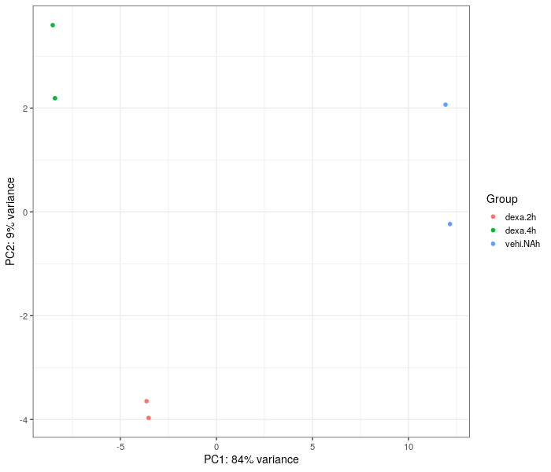

We can see that the principal component plot has been able to place the samples into three separate regions distinctively

**NOTE:** Set proper size parameters for the plot.

**NOTE:** In contrast to Practical 4 where this step aimed for up to 10K of genes, with the project data a smaller set of genes will likely work even better, because the difference between the groups are far less drastic.

In [14]:

%%R

*# Set this yourself.*

percentage <- 0.95

vst.mat <- assay(vst)

*# Get named vector of standard deviations and print it's length (= the total number of genes)*

sds <- apply(vst.mat, MARGIN=1, FUN="sd")

*# Print the total number of genes using 'cat()'. Note that 'cat()' doesn't automatically feed the*

*# line, so the newline character ("\n") must be given at the end to prevent the next line printing*

*# on the same line.*

cat("total number of genes:", length(sds), "\n")

*# Which rows have SD above the selected percentage of all SDs*

sel <- (sds>quantile(sds,percentage))

*# Subset the rows*

vst.subset <- vst.mat[sel, ]

*# Print the number of rows*

cat("number of subset genes:", nrow(vst.subset), "\n")

total number of genes: 28395

number of subset genes: 1420

In [15]:

%%R -w 600 -h 700

library(ComplexHeatmap)

library(circlize)

*# Lets center the counts by substracting row means from the row values*

scaled.vst <- vst.subset-rowMeans(vst.subset)

colnames(scaled.vst) <- gsub("\\.M..*", "", colnames(scaled.vst))

*# Set the color scale*

col_fun = colorRamp2(c(min(scaled.vst),0, max(scaled.vst)), c("blue", "white","red"))

dist.name <- "euclidean"

Heatmap(scaled.vst,

col = col_fun,

show_row_names = F,

clustering_distance_rows = dist.name,

clustering_distance_columns = dist.name,

row_dend_width = unit(3, "cm"),

column_dend_height = unit(3, "cm"),

name="Centred VST counts")

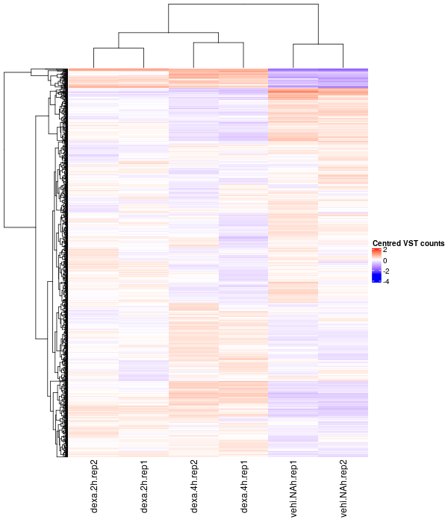

### **Creating DGEList object**

**NOTE:** Even though in Practical 3 we added gene and sample annotation to a DGEList, ***do not*** add anything extra to the object here!

**NOTE:** Below, set the filepath for the output file.

In [16]:

%%R

library(edgeR)

dge <- DGEList(counts = counts, group = gsub("\\.rep..*", "", colnames(counts)))

*#saveRDS(dge, "/home/jupyter*AbiVatsa*/projectTeam4.RDS")*

# **Differential expression analysis**

In [17]:

%%R

library(limma)

library(Homo.sapiens)

x <- readRDS(paste0("/home/jupyterAbiVatsa", "/projectTeam4.RDS"))

x

An object of class "DGEList"

$counts

dexa.2h.rep1.MDAMB231.SRR2046034.2M.sorted.bam

100287102 0

653635 3

102466751 0

100302278 0

645520 0

dexa.2h.rep2.MDAMB231.SRR2046035.2M.sorted.bam

100287102 0

653635 5

102466751 0

100302278 0

645520 0

dexa.4h.rep1.MDAMB231.SRR2046036.2M.sorted.bam

100287102 0

653635 3

102466751 0

100302278 0

645520 0

dexa.4h.rep2.MDAMB231.SRR2046037.2M.sorted.bam

100287102 0

653635 2

102466751 0

100302278 0

645520 0

vehi.NAh.rep1.MDAMB231.SRR2046032.2M.sorted.bam

100287102 0

653635 0

102466751 0

100302278 0

645520 0

vehi.NAh.rep2.MDAMB231.SRR2046033.2M.sorted.bam

100287102 0

653635 2

102466751 0

100302278 0

645520 0

28390 more rows ...

$samples

group lib.size norm.factors

dexa.2h.rep1.MDAMB231.SRR2046034.2M.sorted.bam dexa.2h 1524203 1

dexa.2h.rep2.MDAMB231.SRR2046035.2M.sorted.bam dexa.2h 1293368 1

dexa.4h.rep1.MDAMB231.SRR2046036.2M.sorted.bam dexa.4h 1489497 1

dexa.4h.rep2.MDAMB231.SRR2046037.2M.sorted.bam dexa.4h 1298086 1

vehi.NAh.rep1.MDAMB231.SRR2046032.2M.sorted.bam vehi.NAh 1281261 1

vehi.NAh.rep2.MDAMB231.SRR2046033.2M.sorted.bam vehi.NAh 1511182 1

In [20]:

%%R

dim(x)

[1] 28395 6

### **Organising gene annotations**

In [18]:

%%R

geneid <- rownames(x)

genes <- select(Homo.sapiens, keys=geneid, columns=c("SYMBOL", "TXCHROM"), keytype="ENTREZID")

head(genes)

ENTREZID SYMBOL TXCHROM

1 100287102 DDX11L1 chr1

2 653635 WASH7P chr1

3 102466751 MIR6859-1 <NA>

4 100302278 MIR1302-2 <NA>

5 645520 FAM138A <NA>

6 79501 OR4F5 chr1

In [19]:

%%R

*# Remove duplicates*

genes <- genes[!duplicated(genes$ENTREZID),]

In [20]:

%%R

x$genes <- genes

x

An object of class "DGEList"

$counts

dexa.2h.rep1.MDAMB231.SRR2046034.2M.sorted.bam

100287102 0

653635 3

102466751 0

100302278 0

645520 0

dexa.2h.rep2.MDAMB231.SRR2046035.2M.sorted.bam

100287102 0

653635 5

102466751 0

100302278 0

645520 0

dexa.4h.rep1.MDAMB231.SRR2046036.2M.sorted.bam

100287102 0

653635 3

102466751 0

100302278 0

645520 0

dexa.4h.rep2.MDAMB231.SRR2046037.2M.sorted.bam

100287102 0

653635 2

102466751 0

100302278 0

645520 0

vehi.NAh.rep1.MDAMB231.SRR2046032.2M.sorted.bam

100287102 0

653635 0

102466751 0

100302278 0

645520 0

vehi.NAh.rep2.MDAMB231.SRR2046033.2M.sorted.bam

100287102 0

653635 2

102466751 0

100302278 0

645520 0

28390 more rows ...

$samples

group lib.size norm.factors

dexa.2h.rep1.MDAMB231.SRR2046034.2M.sorted.bam dexa.2h 1524203 1

dexa.2h.rep2.MDAMB231.SRR2046035.2M.sorted.bam dexa.2h 1293368 1

dexa.4h.rep1.MDAMB231.SRR2046036.2M.sorted.bam dexa.4h 1489497 1

dexa.4h.rep2.MDAMB231.SRR2046037.2M.sorted.bam dexa.4h 1298086 1

vehi.NAh.rep1.MDAMB231.SRR2046032.2M.sorted.bam vehi.NAh 1281261 1

vehi.NAh.rep2.MDAMB231.SRR2046033.2M.sorted.bam vehi.NAh 1511182 1

$genes

ENTREZID SYMBOL TXCHROM

1 100287102 DDX11L1 chr1

2 653635 WASH7P chr1

3 102466751 MIR6859-1 <NA>

4 100302278 MIR1302-2 <NA>

5 645520 FAM138A <NA>

28390 more rows ...

## **Data pre-processing**

### **Transformations from the raw-scale**

In [21]:

%%R

cpm <- cpm(x)

lcpm <- cpm(x, log=**TRUE**)

L <- mean(x$samples$lib.size) * 1e-6

M <- median(x$samples$lib.size) * 1e-6

c(L, M)

summary(lcpm)

dexa.2h.rep1.MDAMB231.SRR2046034.2M.sorted.bam

Min. : 0.515

1st Qu.: 0.515

Median : 0.515

Mean : 2.479

3rd Qu.: 4.684

Max. :12.727

dexa.2h.rep2.MDAMB231.SRR2046035.2M.sorted.bam

Min. : 0.515

1st Qu.: 0.515

Median : 0.515

Mean : 2.485

3rd Qu.: 4.667

Max. :12.736

dexa.4h.rep1.MDAMB231.SRR2046036.2M.sorted.bam

Min. : 0.515

1st Qu.: 0.515

Median : 0.515

Mean : 2.468

3rd Qu.: 4.600

Max. :12.933

dexa.4h.rep2.MDAMB231.SRR2046037.2M.sorted.bam

Min. : 0.515

1st Qu.: 0.515

Median : 0.515

Mean : 2.467

3rd Qu.: 4.617

Max. :12.743

vehi.NAh.rep1.MDAMB231.SRR2046032.2M.sorted.bam

Min. : 0.515

1st Qu.: 0.515

Median : 0.515

Mean : 2.494

3rd Qu.: 4.723

Max. :12.621

vehi.NAh.rep2.MDAMB231.SRR2046033.2M.sorted.bam

Min. : 0.515

1st Qu.: 0.515

Median : 0.515

Mean : 2.494

3rd Qu.: 4.696

Max. :12.686

### **Removing genes that are lowly expressed**

In [22]:

%%R

*# Number of genes with zero counts across all samples*

table(rowSums(x$counts==0)==6)

FALSE TRUE

16083 12312

In [23]:

%%R

keep.exprs <- filterByExpr(x, group=x$samples$group)

x <- x[keep.exprs,, keep.lib.sizes=**FALSE**]

dim(x)

[1] 10247 6

In [24]:

%%R

samplenames <- substring(colnames(x), 1, 13)

lcpm.cutoff <- log2(10/M + 2/L)

library(RColorBrewer)

nsamples <- ncol(x)

col <- brewer.pal(nsamples, "Paired")

par(mfrow=c(1,2))

plot(density(lcpm[,1]), col=col[1], lwd=2, ylim=c(0,0.26), las=2, main="", xlab="")

title(main="A. Raw data", xlab="Log-cpm")

abline(v=lcpm.cutoff, lty=3)

for (i in 2:nsamples){

den <- density(lcpm[,i])

lines(den$x, den$y, col=col[i], lwd=2)

}

legend("topright", samplenames, text.col=col, bty="n")

lcpm <- cpm(x, log=**TRUE**)

plot(density(lcpm[,1]), col=col[1], lwd=2, ylim=c(0,0.26), las=2, main="", xlab="")

title(main="B. Filtered data", xlab="Log-cpm")

abline(v=lcpm.cutoff, lty=3)

for (i in 2:nsamples){

den <- density(lcpm[,i])

lines(den$x, den$y, col=col[i], lwd=2)

}

legend("topright", samplenames, text.col=col, bty="n")

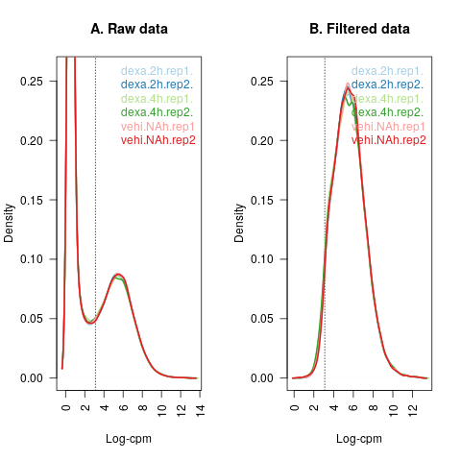

### **Normalising gene expression distributions**

In [25]:

%%R

samplenames <- substring(colnames(x),1,8)

par(mfrow=c(1,2))

lcpm <- cpm(x, log=**TRUE**)

boxplot(lcpm, las=2, col=col, main="", names=samplenames)

title(main="A. Unnormalised data",ylab="Log-cpm")

x <- calcNormFactors(x, method = "TMM")

x$samples$norm.factors

lcpm <- cpm(x, log=**TRUE**)

boxplot(lcpm, las=2, col=col, main="", names=samplenames)

title(main="B. Normalised data",ylab="Log-cpm")

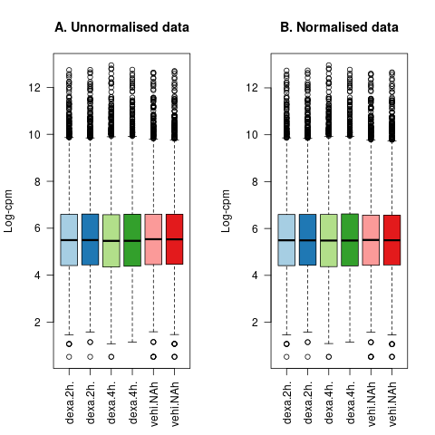

### **Unsupervised clustering of samples**

In [26]:

%%R

lcpm <- cpm(x, log=**TRUE**)

plotMDS(lcpm, labels=x$samples$group)

title(main="A. Sample groups")

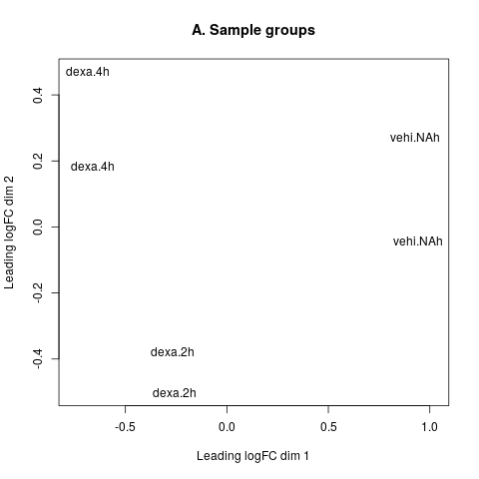

### **Creating design matrix and contrasts**

In [27]:

%%R

design <- model.matrix(~0+x$samples$group)

colnames(design) <- c("dexa.2h","dexa.4h","vehi.NAh")

design

dexa.2h dexa.4h vehi.NAh

1 1 0 0

2 1 0 0

3 0 1 0

4 0 1 0

5 0 0 1

6 0 0 1

attr(,"assign")

[1] 1 1 1

attr(,"contrasts")

attr(,"contrasts")$`x$samples$group`

[1] "contr.treatment"

In [28]:

%%R

contr.matrix <- makeContrasts(

dexa2hvsdexa4h = dexa.2h-dexa.4h,

dexa2hvsvehiNAh = dexa.2h - vehi.NAh,

dexa4hvsvehiNAh = dexa.4h - vehi.NAh,

levels = colnames(design))

contr.matrix

Contrasts

Levels dexa2hvsdexa4h dexa2hvsvehiNAh dexa4hvsvehiNAh

dexa.2h 1 1 0

dexa.4h -1 0 1

vehi.NAh 0 -1 -1

### **Removing heteroscedascity from count data and fitting linear models for comparisons of interest**

In [29]:

%%R

par(mfrow=c(1,2))

v <- voom(x, design, plot=**TRUE**)

v

vfit <- lmFit(v, design)

vfit <- contrasts.fit(vfit, contrasts=contr.matrix)

efit <- eBayes(vfit)

plotSA(efit, main="Final model: Mean-variance trend")

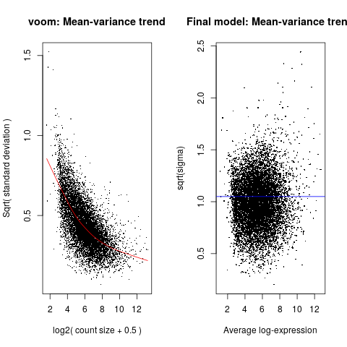

### **Examining the number of DE genes**

In [30]:

%%R

dt <- decideTests(efit)

summary(dt)

dexa2hvsdexa4h dexa2hvsvehiNAh dexa4hvsvehiNAh

Down 125 160 430

NotSig 9976 9854 9357

Up 146 233 460

In [31]:

%%R

de.common <- which(dt[,1]!=0 & dt[,2]!=0 & dt[,3]!=0)

length(de.common)

head(efit$genes$SYMBOL[de.common], n=20)

vennDiagram(dt[,1:3], circle.col=c("turquoise", "salmon", "khaki"), cex=1.2)

*#write.fit(efit, dt, file="results.txt")*

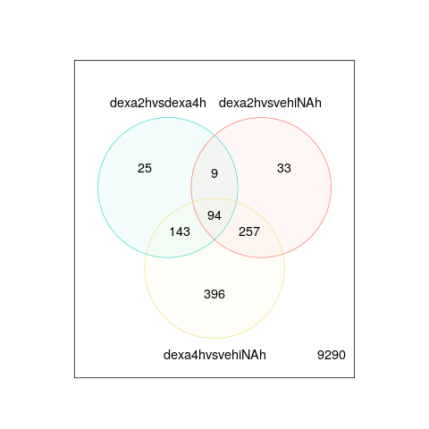

### **Examining individual DE genes from top to bottom**

In [32]:

%%R

dexa2h.vs.dexa4h <- topTable(efit, coef=1, n=**Inf**)

head(dexa2h.vs.dexa4h)

*#write.table(dexa2h.vs.dexa4h, "dexa2h_vs_dexa4h.txt", row.names=FALSE)*

ENTREZID SYMBOL TXCHROM logFC AveExpr t P.Value

2289 2289 FKBP5 chr6 -1.4956442 9.089879 -20.914904 7.366190e-21

23268 23268 DNMBP chr10 1.1555592 7.672515 9.406968 6.037072e-11

128434 128434 VSTM2L chr20 -0.9315925 7.880523 -8.954277 2.002004e-10

2180 2180 ACSL1 chr4 -1.0539323 7.112129 -8.854097 2.619628e-10

4502 4502 MT2A chr16 -0.6582336 9.765853 -8.013044 2.631917e-09

10458 10458 BAIAP2 chr17 -0.8996397 7.300353 -7.967011 2.993646e-09

adj.P.Val B

2289 7.548135e-17 37.11553

23268 3.093094e-07 14.89399

128434 6.710833e-07 13.81566

2180 6.710833e-07 13.51276

4502 5.112648e-06 11.19955

10458 5.112648e-06 11.18456

In [33]:

%%R

dexa2h.vs.vehiNAh <- topTable(efit, coef=2, n=**Inf**)

head(dexa2h.vs.vehiNAh)

*#write.table(dexa2h.vs.dexa4h, "dexa2h_vs_vehiNAh.txt", row.names=FALSE)*

ENTREZID SYMBOL TXCHROM logFC AveExpr t P.Value

2289 2289 FKBP5 chr6 3.608075 9.089879 28.79927 2.731329e-25

1831 1831 TSC22D3 chrX 5.103374 8.276275 28.61514 3.361483e-25

10628 10628 TXNIP chr1 2.154054 9.854216 25.41540 1.530394e-23

54541 54541 DDIT4 chr10 2.933701 8.510682 25.57361 1.254446e-23

54206 54206 ERRFI1 chr1 2.183652 10.542454 23.29931 2.447544e-22

6574 6574 SLC20A1 chr2 1.967338 9.704938 20.93196 7.180544e-21

adj.P.Val B

2289 1.722256e-21 46.99274

1831 1.722256e-21 45.60715

10628 3.920486e-20 43.70135

54541 3.920486e-20 43.59584

54206 5.015997e-19 40.96807

6574 1.226317e-17 37.60254

In [34]:

%%R

dexa4h.vs.vehiNAh <- topTable(efit, coef=3, n=**Inf**)

head(dexa4h.vs.vehiNAh)

*#write.table(dexa2h.vs.dexa4h, "dexa4h_vs_vehiNAh.txt", row.names=FALSE)*

ENTREZID SYMBOL TXCHROM logFC AveExpr t P.Value

2289 2289 FKBP5 chr6 5.103720 9.089879 42.22011 9.898201e-31

1831 1831 TSC22D3 chrX 5.112578 8.276275 28.65396 3.217208e-25

4502 4502 MT2A chr16 2.303075 9.765853 24.09557 8.407090e-23

54541 54541 DDIT4 chr10 2.744438 8.510682 23.72622 1.374644e-22

4493 4493 MT1E chr16 3.123666 8.065572 22.81402 4.770071e-22

10628 10628 TXNIP chr1 1.843248 9.854216 21.35405 3.839375e-21

adj.P.Val B

2289 1.014269e-26 58.58826

1831 1.648336e-21 46.10259

4502 2.871582e-19 42.03288

54541 3.521494e-19 41.40897

4493 9.775783e-19 40.12544

10628 6.167484e-18 38.21966

In [35]:

%%R

plotMD(efit, column=1, status=dt[,1], main=colnames(efit)[1],

xlim=c(0,13))

plotMD(efit, column=2, status=dt[,2], main=colnames(efit)[2],

xlim=c(0,13))

plotMD(efit, column=3, status=dt[,3], main=colnames(efit)[3],

xlim=c(0,13))

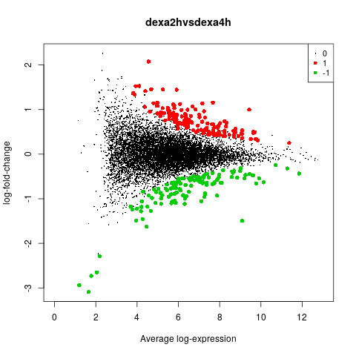

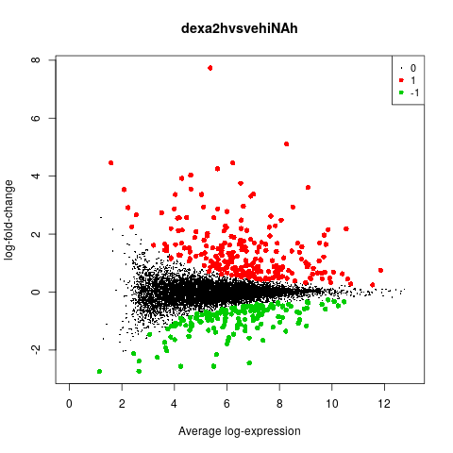

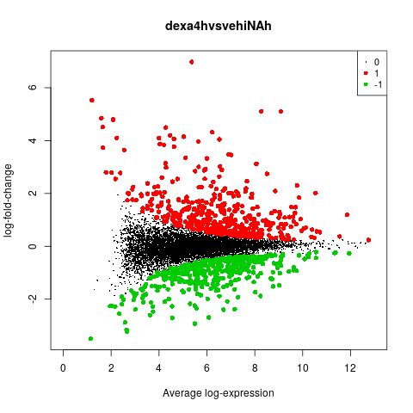

In [42]:

%%R

dex <- dexa4h.vs.vehiNAh$ENTREZID[1:100]

i <- x[x$genes$ENTREZID %in% dex,]

In [62]:

%%R -w 600 -h 800

*# Heatmap of top 100 DE genes in Dex4h vs. vehiNAh*

lcpm.values <- cpm(i$counts, log=**TRUE**)

colnames(lcpm.values) <- gsub("\\.M..*", "", colnames(lcpm.values))

rownames(lcpm.values) <- i$genes$SYMBOL

dist.name <- "euclidean"

Heatmap(lcpm.values,

name="Log-CPM values",

row_names_gp = gpar(fontsize = 8),

clustering_distance_rows = dist.name,

clustering_distance_columns = dist.name)

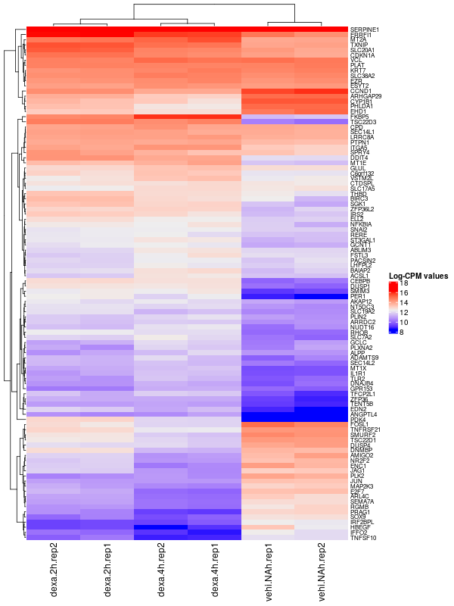

In [ ]:

%%R

*# Selecting genes with logFC >= 1 or logFC <= -1 from each comparison and saving them to a file*

dexa4h.vs.vehiNAhlogFCg1 = dexa4h.vs.vehiNAh[dexa4h.vs.vehiNAh$logFC > 1,]

write.csv(dexa4h.vs.vehiNAhlogFCg1$SYMBOL, "~/course_data/SEQDA23Teams/Team4/dexa4h.vs.vehiNAhEnriched.csv", row.names=**FALSE**)

dexa4h.vs.vehiNAhlogFClminus1 = dexa4h.vs.vehiNAh[dexa4h.vs.vehiNAh$logFC < -1,]

write.csv(dexa4h.vs.vehiNAhlogFClminus1$SYMBOL, "~/course_data/SEQDA23Teams/Team4/dexa4h.vs.vehiNAhRepressed.csv", row.names=**FALSE**)

dexa2h.vs.vehiNAhlogFClminus1 = dexa2h.vs.vehiNAh[dexa2h.vs.vehiNAh$logFC < -1,]

write.csv(dexa2h.vs.vehiNAhlogFClminus1$SYMBOL, "~/course_data/SEQDA23Teams/Team4/dexa2h.vs.vehiNAhRepressed.csv", row.names=**FALSE**)

dexa2h.vs.vehiNAhlogFCg1 = dexa2h.vs.vehiNAh[dexa2h.vs.vehiNAh$logFC > 1,]

write.csv(dexa2h.vs.vehiNAhlogFCg1$SYMBOL, "~/course_data/SEQDA23Teams/Team4/dexa2h.vs.vehiNAhEnriched.csv", row.names=**FALSE**)

dexa2h.vs.dexa4hlogFCg1 = dexa2h.vs.dexa4h[dexa2h.vs.dexa4h$logFC > 1,]

write.csv(dexa2h.vs.dexa4hlogFCg1$SYMBOL, "~/course_data/SEQDA23Teams/Team4/dexa2h.vs.dexa4hEnriched.csv", row.names=**FALSE**)

dexa2h.vs.dexa4hlogFClminus1 = dexa2h.vs.dexa4h[dexa2h.vs.dexa4h$logFC < -1,]

write.csv(dexa2h.vs.dexa4hlogFClminus1$SYMBOL, "~/course_data/SEQDA23Teams/Team4/dexa2h.vs.dexa4hRepressed.csv", row.names=**FALSE**)